Microsoft Onboarding Process

Deployment Guide

Author: Martin Karaivanov

Date: 27.09.2018

Contents

1. Azure 3

1.1 Azure Storage account 3

1.2 Azure Blob Container 3

1.3 Azure Function 3

2. Microsoft Flow 5

2.1 Import 5

2.2 Configure accounts, credentials and other settings 5

# Azure

## Azure Storage account

Create a new storage account or use an existing one

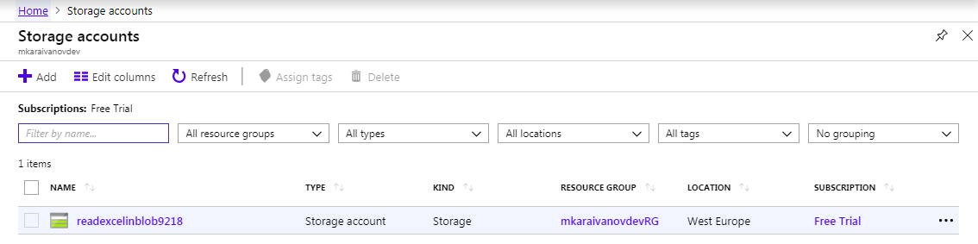

## Azure Blob Container

In the Azure Storage account create a new Azure Blob Container

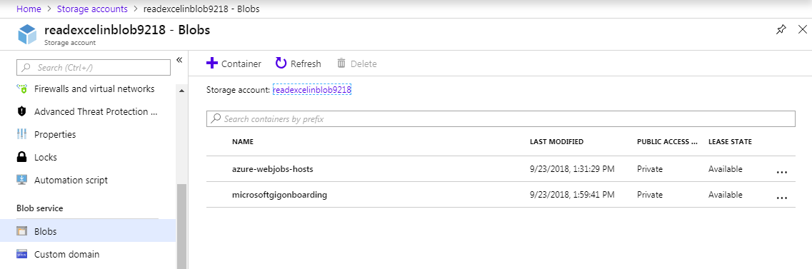

## Azure Function

* + 1. Azure Function App

Create a new Azure Function App

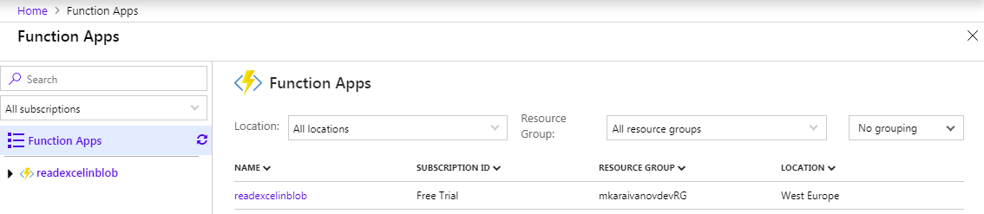

* + 1. Azure Function
  1. In the new Azure Function App create a new Azure Function

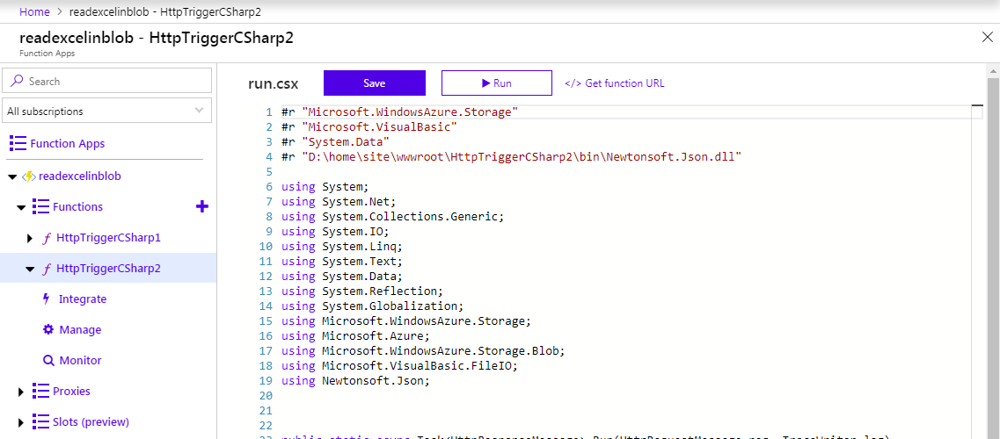

* 1. Copy the provided source code from github (“…/azure function/run.csx”) into the body of the newly created Azure Function and save it.
  2. Replace text “HttpTriggerCSharp2” with the name of your Azure Function.
  3. Open Kudu Services for the Azure Function App (url https://{your_azure_function_app_name}.scm.azurewebsites.net/DebugConsole), create folder “bin” inside folder “wwwroot” for that function and copy the contents of the “bin“ folder from github (“…/azure function/bin/”).

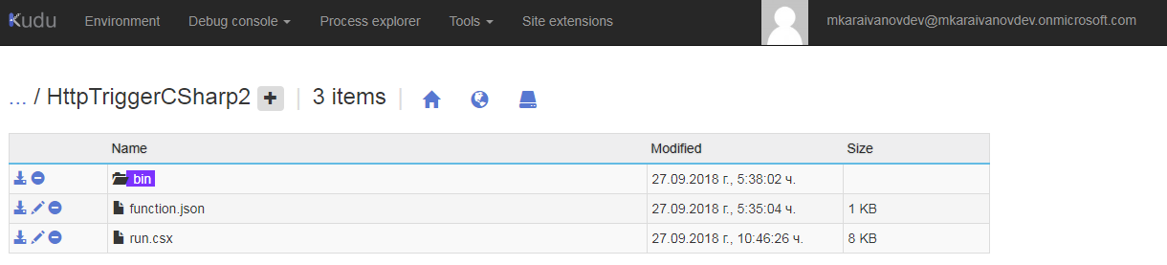

* 1. Back to the Azure Portal, open the Application settings for the Azure Function App and add the following settings:
* AzureStorageAccessKey (available in the settings of the Azure Storage)
* AzureStorageConnectionString (available in the settings of the Azure Storage)
* AzureStorageContainerName (the name of the container created in the previous step of this manual)

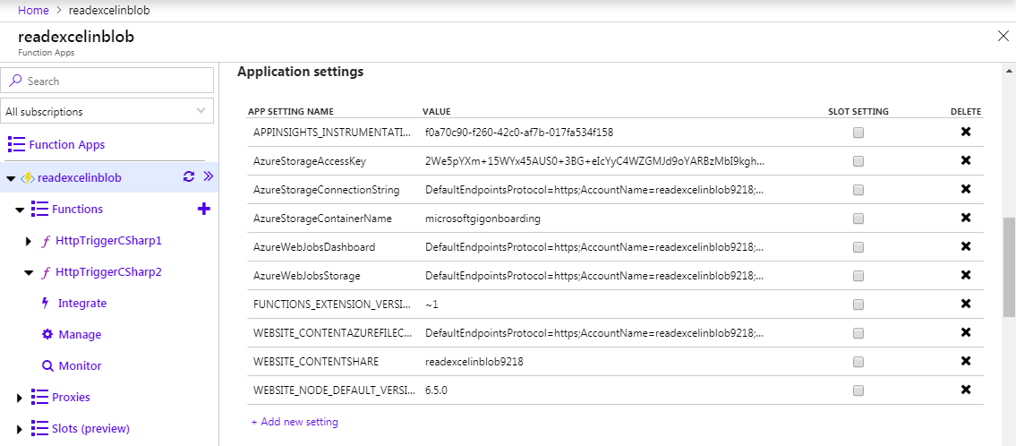

# Microsoft Flow

## Import

Import Microsoft Flow package “Microsoft-Onboarding_20180927131848.zip” from github (“…/flow/”).



## Configure accounts, credentials and other settings

After the Flow is imported, all accounts that are used by the Flow should be configured for that environment.

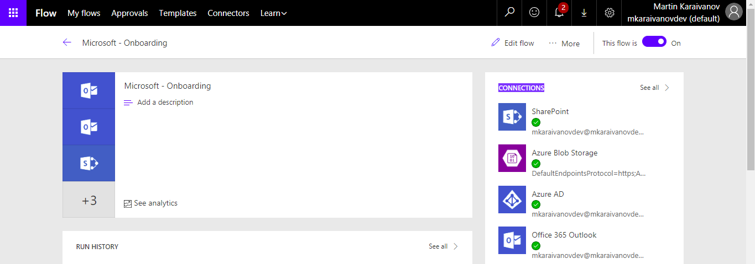

* + 1. Office 365 account

Flow will use that account in order to connect to a SharePoint document library where all received CSV files will be stored.

* + 1. Office 365 mailbox account

Flow will wait for new onboarding email messages in that mailbox and will trigger the onboarding business process logic.

* + 1. Azure Blob Storage account

That account (the one created in the previous step of the manual) is used by Flow to save each CSV file in order to be further processed by the Azure Function.

* + 1. Azure AD account

Flow will use that account in order to add each approved employee (taken from the CSV file) to the Azure AD group Upwork Pilot Program.

* + 1. SharePoint site

The URL address of the SharePoint site where to copy the CSV files (e.g. “https://{your_domain}.sharepoint.com/sites/{your_site}”).

The following activity should be configured:

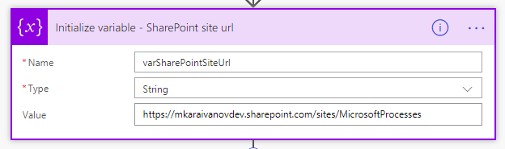

* + 1. SharePoint document library folder

The path to the SharePoint document library folder where to copy the CSV files (e.g. “/Shared Documents/Reports”). If that folder does not exist, it should be created manually.

The following activity should be configured:

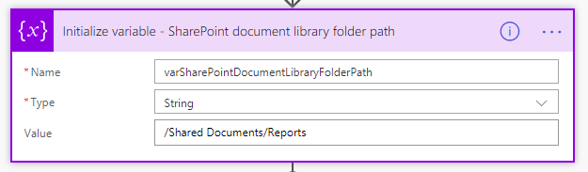

* + 1. Azure Function URL address

The URL address of the Azure Function used for CSV processing (the one created in the previous step of the manual).

The following activity should be configured:

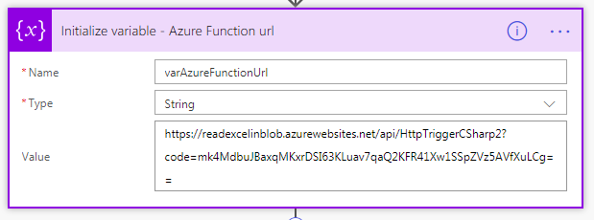

* + 1. Azure AD group id (“Upwork Pilot Program”) id

Flow will use that Azure AD group id to identify group Upwork Pilot Program. The value in the production environment should be set to “f2830bc6-326d-419d-819e-d6b1d3e25c24”.

The following activity should be configured:

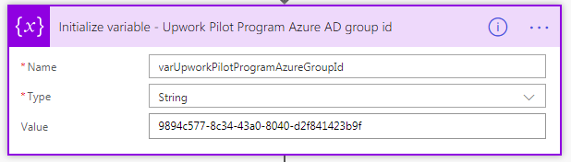

* + 1. Upwork email address

Flow will use that email address in order to send an email notification to the Upwork team for each approved employee.

The following activity should be configured:

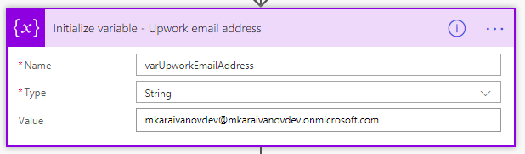

* + 1. Enable email sending

Depending on that setting, Flow will or will not send email notifications to the students and to Upwork. It is provided in order to test the system without sending test email notifications to real people.

The following activity should be configured:

